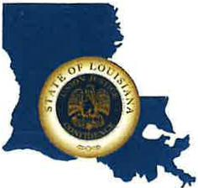 | CAPITAL AREA GROUNDWATER CONSERVATION DISTRICT
GARY I. BEARD
EXECUTIVE DIRECTOR

MEETING NOTICE
Capital Area Groundwater Conservation District Board Board Meeting

WHEN: April 20, 2023

TIME: 2:00 pm

WHERE: Renaissance Baton Rouge
7000 Bluebonnet Blvd.
Baton Rouge, LA 70810

Contact Person: Lisa Manda, (225) 293-7370

